**Database Management System Laboratory**

**GROUP A  
Experiment No: 3**

Name: Onasvee Banarse

TE COMPUTER SHIFT 1

Roll no: 09

**Aim**: Design at least 10 SQL queries for suitable database application using SQL DML statements: all types of Joins, Sub-Query, View.

**Objective:**

1. To learn and understand DML statements in MySQL.
2. To learn SQL Joins, Subqueries & Views.

**Requirement:** Any OS, MySQL, Workbench, Oracle Workbench (Online).

**Theory:**

**SQL Join**

A SQL Join statement is used to combine data or rows from two or more tables based on a common field between them. Different types of Joins are:

* INNER JOIN
* LEFT JOIN
* RIGHT JOIN
* FULL JOIN

Consider the two tables below:

**Student**

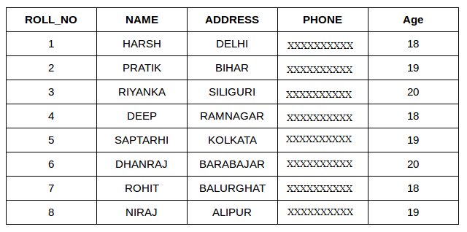

**StudentCourse**

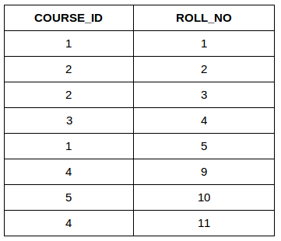

The simplest Join is INNER JOIN.

* **INNER JOIN:**

The INNER JOIN keyword selects all rows from both the tables as long as the condition satisfies. This keyword will create the result-set by combining all rows from both the tables where the condition satisfies i.e value of the common field will be same.  
**Syntax**:

SELECT table1.column1,table1.column2,table2.column1,....

FROM table1

INNER JOIN table2

ON table1.matching_column = table2.matching_column;

**table1**: First table.

**table2**: Second table

**matching_column**: Column common to both the tables.

This query will show the names and age of students enrolled in different courses.

SELECT StudentCourse.COURSE_ID, Student.NAME, Student.AGE FROM Student

INNER JOIN StudentCourse

ON Student.ROLL_NO = StudentCourse.ROLL_NO;

**Output**:

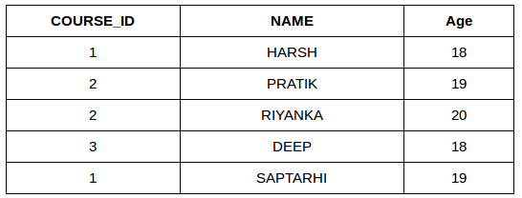

* **LEFT JOIN:**

This join returns all the rows of the table on the left side of the join and matching rows for the table on the right side of join. The rows for which there is no matching row on right side, the result-set will contain *null*. LEFT JOIN is also known as LEFT OUTER JOIN.

Syntax:

SELECT table1.column1,table1.column2,table2.column1,....

FROM table1

LEFT JOIN table2

ON table1.matching_column = table2.matching_column;

table1: First table.

table2: Second table

matching_column: Column common to both the tables.

SELECT Student.NAME,StudentCourse.COURSE_ID

FROM Student

LEFT JOIN StudentCourse

ON StudentCourse.ROLL_NO = Student.ROLL_NO;

**Output:**

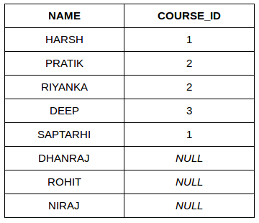

* **RIGHT JOIN**:

RIGHT JOIN is similar to LEFT JOIN. This join returns all the rows of the table on the right side of the join and matching rows for the table on the left side of join. The rows for which there is no matching row on left side, the result-set will contain *null*. RIGHT JOIN is also known as RIGHT OUTER JOIN.

**Syntax:**

SELECT table1.column1,table1.column2,table2.column1,....

FROM table1

RIGHT JOIN table2

ON table1.matching_column = table2.matching_column;

table1: First table.

table2: Second table

matching_column: Column common to both the tables.

SELECT Student.NAME,StudentCourse.COURSE_ID

FROM Student

RIGHT JOIN StudentCourse

ON StudentCourse.ROLL_NO = Student.ROLL_NO;

**Output:**

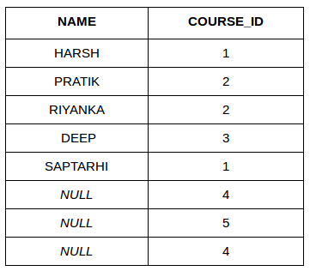

* **FULL JOIN:**

 FULL JOIN creates the result-set by combining result of both LEFT JOIN and RIGHT JOIN. The result-set will contain all the rows from both the tables. The rows for which there is no matching, the result-set will contain *NULL* values.

**Syntax:**

SELECT table1.column1,table1.column2,table2.column1,....

FROM table1

FULL JOIN table2

ON table1.matching_column = table2.matching_column;

table1: First table.

table2: Second table

matching_column: Column common to both the tables.

SELECT Student.NAME,StudentCourse.COURSE_ID

FROM Student

FULL JOIN StudentCourse

ON StudentCourse.ROLL_NO = Student.ROLL_NO;

**Output:**

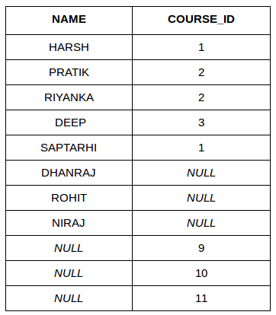

**SQL Sub Queries**

A Subquery or Inner query or a Nested query is a query within another SQL query and embedded within the WHERE clause.

A subquery is used to return data that will be used in the main query as a condition to further restrict the data to be retrieved.

Subqueries can be used with the SELECT, INSERT, UPDATE, and DELETE statements along with the operators like =, <, >, >=, <=, IN, BETWEEN, etc.

There are a few rules that subqueries must follow −

* Subqueries must be enclosed within parentheses.
* A subquery can have only one column in the SELECT clause unless multiple columns are in the main query for the subquery to compare its selected columns.
* An ORDER BY command cannot be used in a subquery, although the main query can use an ORDER BY. The GROUP BY command can be used to perform the same function as the ORDER BY in a subquery.
* Subqueries that return more than one row can only be used with multiple value operators such as the IN operator.
* The SELECT list cannot include any references to values that evaluate to a BLOB, ARRAY, CLOB, or NCLOB.
* A subquery cannot be immediately enclosed in a set function.
* The BETWEEN operator cannot be used with a subquery. However, the BETWEEN operator can be used within the subquery.

**Subqueries with the SELECT Statement**

Subqueries are most frequently used with the SELECT statement. The basic syntax is as follows −

SELECT column_name [, column_name ]

FROM table1 [, table2 ]

WHERE column_name OPERATOR

(SELECT column_name [, column_name ]

FROM table1 [, table2 ]

[WHERE])

Example

Consider the CUSTOMERS table having the following records −

+----+----------+-----+-----------+----------+

| ID | NAME | AGE | ADDRESS | SALARY |

+----+----------+-----+-----------+----------+

| 1 | Ramesh | 35 | Ahmedabad | 2000.00 |

| 2 | Khilan | 25 | Delhi | 1500.00 |

| 3 | kaushik | 23 | Kota | 2000.00 |

| 4 | Chaitali | 25 | Mumbai | 6500.00 |

| 5 | Hardik | 27 | Bhopal | 8500.00 |

| 6 | Komal | 22 | MP | 4500.00 |

| 7 | Muffy | 24 | Indore | 10000.00 |

+----+----------+-----+-----------+----------+

Now, let us check the following subquery with a SELECT statement.

SQL> SELECT *

FROM CUSTOMERS

WHERE ID IN (SELECT ID

FROM CUSTOMERS

WHERE SALARY > 4500) ;

This would produce the following result.

+----+----------+-----+---------+----------+

| ID | NAME | AGE | ADDRESS | SALARY |

+----+----------+-----+---------+----------+

| 4 | Chaitali | 25 | Mumbai | 6500.00 |

| 5 | Hardik | 27 | Bhopal | 8500.00 |

| 7 | Muffy | 24 | Indore | 10000.00 |

+----+----------+-----+---------+----------+

**Subqueries with the INSERT Statement**

Subqueries also can be used with INSERT statements. The INSERT statement uses the data returned from the subquery to insert into another table. The selected data in the subquery can be modified with any of the character, date, or number functions.

The basic syntax is as follows.

INSERT INTO table_name [ (column1 [, column2 ]) ]

SELECT [ *|column1 [, column2 ]

FROM table1 [, table2 ]

[ WHERE VALUE OPERATOR ]

Example

Consider a table CUSTOMERS_BKP with similar structure as CUSTOMERS table. Now to copy the complete CUSTOMERS table into the CUSTOMERS_BKP table, you can use the following syntax.

SQL> INSERT INTO CUSTOMERS_BKP

SELECT * FROM CUSTOMERS

WHERE ID IN (SELECT ID

FROM CUSTOMERS) ;

**Subqueries with the UPDATE Statement**

The subquery can be used in conjunction with the UPDATE statement. Either single or multiple columns in a table can be updated when using a subquery with the UPDATE statement.

The basic syntax is as follows.

UPDATE table

SET column_name = new_value

[ WHERE OPERATOR [ VALUE ]

(SELECT COLUMN_NAME

FROM TABLE_NAME)

[ WHERE) ]

Example

Assuming, we have CUSTOMERS_BKP table available which is backup of CUSTOMERS table. The following example updates SALARY by 0.25 times in the CUSTOMERS table for all the customers whose AGE is greater than or equal to 27.

SQL> UPDATE CUSTOMERS

SET SALARY = SALARY * 0.25

WHERE AGE IN (SELECT AGE FROM CUSTOMERS_BKP

WHERE AGE >= 27 );

This would impact two rows and finally CUSTOMERS table would have the following records.

+----+----------+-----+-----------+----------+

| ID | NAME | AGE | ADDRESS | SALARY |

+----+----------+-----+-----------+----------+

| 1 | Ramesh | 35 | Ahmedabad | 125.00 |

| 2 | Khilan | 25 | Delhi | 1500.00 |

| 3 | kaushik | 23 | Kota | 2000.00 |

| 4 | Chaitali | 25 | Mumbai | 6500.00 |

| 5 | Hardik | 27 | Bhopal | 2125.00 |

| 6 | Komal | 22 | MP | 4500.00 |

| 7 | Muffy | 24 | Indore | 10000.00 |

+----+----------+-----+-----------+----------+

**Subqueries with the DELETE Statement**

The subquery can be used in conjunction with the DELETE statement like with any other statements mentioned above.

The basic syntax is as follows.

DELETE FROM TABLE_NAME

[ WHERE OPERATOR [ VALUE ]

(SELECT COLUMN_NAME

FROM TABLE_NAME)

[ WHERE) ]

Example

Assuming, we have a CUSTOMERS_BKP table available which is a backup of the CUSTOMERS table. The following example deletes the records from the CUSTOMERS table for all the customers whose AGE is greater than or equal to 27.

SQL> DELETE FROM CUSTOMERS

WHERE AGE IN (SELECT AGE FROM CUSTOMERS_BKP

WHERE AGE >= 27 );

This would impact two rows and finally the CUSTOMERS table would have the following records.

+----+----------+-----+---------+----------+

| ID | NAME | AGE | ADDRESS | SALARY |

+----+----------+-----+---------+----------+

| 2 | Khilan | 25 | Delhi | 1500.00 |

| 3 | kaushik | 23 | Kota | 2000.00 |

| 4 | Chaitali | 25 | Mumbai | 6500.00 |

| 6 | Komal | 22 | MP | 4500.00 |

| 7 | Muffy | 24 | Indore | 10000.00 |

+----+----------+-----+---------+----------+

**SQL - Using Views**

A view is nothing more than a SQL statement that is stored in the database with an associated name. A view is a composition of a table in the form of a predefined SQL query.

A view can contain all rows of a table or select rows from a table. A view can be created from one or many tables which depends on the written SQL query to create a view.

Views, which are a type of virtual tables allow users to do the following −

* Structure data in a way that users or classes of users find natural or intuitive.
* Restrict access to the data in such a way that a user can see and (sometimes) modify exactly what they need and no more.
* Summarize data from various tables which can be used to generate reports.

**Creating View**

Database views are created using the **CREATE VIEW** statement. Views can be created from a single table, multiple tables or another view.

To create a view, a user must have the appropriate system privilege according to the specific implementation.

The basic **CREATE VIEW** syntax is as follows −

CREATE VIEW view_name AS

SELECT column1, column2.....

FROM table_name

WHERE [condition];

You can include multiple tables in your SELECT statement in a similar way as you use them in a normal SQL SELECT query.

Example

Consider the CUSTOMERS table having the following records −

+----+----------+-----+-----------+----------+

| ID | NAME | AGE | ADDRESS | SALARY |

+----+----------+-----+-----------+----------+

| 1 | Ramesh | 32 | Ahmedabad | 2000.00 |

| 2 | Khilan | 25 | Delhi | 1500.00 |

| 3 | kaushik | 23 | Kota | 2000.00 |

| 4 | Chaitali | 25 | Mumbai | 6500.00 |

| 5 | Hardik | 27 | Bhopal | 8500.00 |

| 6 | Komal | 22 | MP | 4500.00 |

| 7 | Muffy | 24 | Indore | 10000.00 |

+----+----------+-----+-----------+----------+

Following is an example to create a view from the CUSTOMERS table. This view would be used to have customer name and age from the CUSTOMERS table.

SQL > CREATE VIEW CUSTOMERS_VIEW AS

SELECT name, age

FROM CUSTOMERS;

Now, you can query CUSTOMERS_VIEW in a similar way as you query an actual table. Following is an example for the same.

SQL > SELECT * FROM CUSTOMERS_VIEW;

This would produce the following result.

+----------+-----+

| name | age |

+----------+-----+

| Ramesh | 32 |

| Khilan | 25 |

| kaushik | 23 |

| Chaitali | 25 |

| Hardik | 27 |

| Komal | 22 |

| Muffy | 24 |

+----------+-----+

**The WITH CHECK OPTION**

The WITH CHECK OPTION is a CREATE VIEW statement option. The purpose of the WITH CHECK OPTION is to ensure that all UPDATE and INSERTs satisfy the condition(s) in the view definition.

If they do not satisfy the condition(s), the UPDATE or INSERT returns an error.

The following code block has an example of creating same view CUSTOMERS_VIEW with the WITH CHECK OPTION.

CREATE VIEW CUSTOMERS_VIEW AS

SELECT name, age

FROM CUSTOMERS

WHERE age IS NOT NULL

WITH CHECK OPTION;

The WITH CHECK OPTION in this case should deny the entry of any NULL values in the view's AGE column because the view is defined by data that does not have a NULL value in the AGE column.

**Updating a VIEW**

A view can be updated under certain conditions which are given below −

* The SELECT clause may not contain the keyword DISTINCT.
* The SELECT clause may not contain summary functions.
* The SELECT clause may not contain set functions.
* The SELECT clause may not contain set operators.
* The SELECT clause may not contain an ORDER BY clause.
* The FROM clause may not contain multiple tables.
* The WHERE clause may not contain subqueries.
* The query may not contain GROUP BY or HAVING.
* Calculated columns may not be updated.
* All NOT NULL columns from the base table must be included in the view for the INSERT query to function.

So, if a view satisfies all the above-mentioned rules, then you can update that view. The following code block has an example to update the age of Ramesh.

SQL > UPDATE CUSTOMERS_VIEW

SET AGE = 35

WHERE name = 'Ramesh';

This would ultimately update the base table CUSTOMERS and the same would reflect in the view itself. Now, try to query the base table and the SELECT statement would produce the following result.

+----+----------+-----+-----------+----------+

| ID | NAME | AGE | ADDRESS | SALARY |

+----+----------+-----+-----------+----------+

| 1 | Ramesh | 35 | Ahmedabad | 2000.00 |

| 2 | Khilan | 25 | Delhi | 1500.00 |

| 3 | kaushik | 23 | Kota | 2000.00 |

| 4 | Chaitali | 25 | Mumbai | 6500.00 |

| 5 | Hardik | 27 | Bhopal | 8500.00 |

| 6 | Komal | 22 | MP | 4500.00 |

| 7 | Muffy | 24 | Indore | 10000.00 |

+----+----------+-----+-----------+----------+

**Inserting Rows in VIEW**

Rows of data can be inserted into a view. The same rules that apply to the UPDATE command also apply to the INSERT command.

Here, we cannot insert rows in the CUSTOMERS_VIEW because we have not included all the NOT NULL columns in this view, otherwise you can insert rows in a view in a similar way as you insert them in a table.

**Deleting Rows into a View**

Rows of data can be deleted from a view. The same rules that apply to the UPDATE and INSERT commands apply to the DELETE command.

Following is an example to delete a record having AGE = 22.

SQL > DELETE FROM CUSTOMERS_VIEW

WHERE age = 22;

This would ultimately delete a row from the base table CUSTOMERS and the same would reflect in the view itself. Now, try to query the base table and the SELECT statement would produce the following result.

+----+----------+-----+-----------+----------+

| ID | NAME | AGE | ADDRESS | SALARY |

+----+----------+-----+-----------+----------+

| 1 | Ramesh | 35 | Ahmedabad | 2000.00 |

| 2 | Khilan | 25 | Delhi | 1500.00 |

| 3 | kaushik | 23 | Kota | 2000.00 |

| 4 | Chaitali | 25 | Mumbai | 6500.00 |

| 5 | Hardik | 27 | Bhopal | 8500.00 |

| 7 | Muffy | 24 | Indore | 10000.00 |

+----+----------+-----+-----------+----------+

**Dropping Views**

Where we have a view, we need a way to drop the view if it is no longer needed. The syntax is given below −

DROP VIEW view_name;

Following is an example to drop the CUSTOMERS_VIEW from the CUSTOMERS table.

DROP VIEW CUSTOMERS_VIEW;

**SQL QUERIES:**

**Conclusion:**

Thus, we have successfully studied Joins, Subqueries and views and implemented SQL Queries.